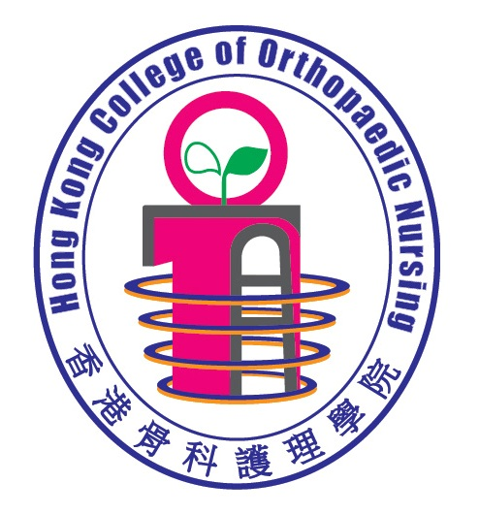 | HONG KONG COLLEGE OF ORTHOPAEDIC NURSING  APPLICATION FORM FOR ASSOCIATE MEMBER

IMPORTANT NOTES TO APPLICANTS:
- The college is one of members of The Hong Kong Academy of Nursing and has the authority to nominate suitable applicants to the academy. The final approval lies with the academy.
- The applicant should have valid RN/RM Registration in Hong Kong with valid practicing certificate;
- The applicant should be a degree holder with at least 2 years post registration experience.
- The application form should be typed or written in BLOCK LETTERS and circle * as appropriate. Please use separate sheets for details if necessary. The College will not process any incomplete application.
- All information given in this form will be treated STRICTLY CONFIDENTIAL.

- Personal Particulars
* Please type or complete the form in BLOCK LETTERS and circle as appropriate
Title:* Ms /Mr /Mrs /Dr./Prof. | Surname: |  |  |  | Given Name:
Name in Chinese: |  |  |  |  | Sex * F / M
Job Title:
Present Working Place/Area:
HK ID No.: | □□-□□□XXX (X)  (Please enter the first 4 or 5 alpha-numeric characters e.g.AA-123 XXX(X))
Correspondence Address :
Contact : | Mobile Phone No.: |  |  |  |  | Office Tel. No.:
 | Email Address:
Registration No. of Registered Nurse Certificate Issued by HK Nursing Council:
Expiry Date of Practising Certificate: |  |  |  |  |  |  |  | (DD/MM/YY)

- Academic and Professional Qualifications (In descending chronological order)
A. Nursing related Academic & Professional Qualifications | Course/ Programme Title | Training Institute/ Country | Qualification  Date obtained – Month-Year
A. Nursing related Academic & Professional Qualifications | 1.
A. Nursing related Academic & Professional Qualifications | 2.
A. Nursing related Academic & Professional Qualifications | 3.

B. Orthopaedic Related Specialty Training | Course/ Programme Title | Training Institute/ Country | Qualification  Date obtained – Month-Year
B. Orthopaedic Related Specialty Training | 1.
B. Orthopaedic Related Specialty Training | 2.
B. Orthopaedic Related Specialty Training | 3.

- Post-registration Working Experience in Nursing Relevant to Application
(In descending chronological order)
Position | Specialty / Department | Working Institution / Hospital | Period  (DD/MM/YYYY) | Months
1.

2.

3.

4.

Remark: All orthopaedic experiences in clinical, management, teaching or research nursing would be considered.

SUPPORTIVE DOCUMENTS
I enclose the following documents to support my application:
 (1) Copy of valid Registered Nurse Registration Certificate
 (2) Copy of valid Registered Nurse Practicing Certificate
 (3) Copy of the certificate of the highest academic qualification
 (3) Copy or copies of specialty nursing related certificate(s)
 (4) Copy or copies of curriculum vitae
 (5) others:

The subscription is free of charge. The Associate Membership will be ceased once accepted as Ordinary Member.

Please mail this application form and the supportive documents to:
Administrative Office, Hong Kong College of Orthopaedic Nursing Limited,
Address: LG1, School of Nursing, Princess Margaret Hospital,
232 Lai King Hill Road, Lai Chi Kok, Kowloon, Hong Kong.

DECLARATION (* Delete as appropriate)

- I hereby declare that I agree to provide the above information to Hong Kong College of Orthopaedic Nursing and the information provided in support of this application is accurate to this date.
- I understand that the information provided herewith will be forwarded to the Hong Kong Academy of Nursing for processing my membership certification examination application.
- I understand that it is my responsibility to inform the College of any change in the above information, such as place of work, correspondence address and additional related qualification(s), etc. The College will not have to be responsible for any issues arise as a result of my failure to inform.
- I have*/ have not* been convicted of a criminal offence punishable with imprisonment (irrespective of whether actually sentenced to imprisonment) in Hong Kong or elsewhere.
- I am*/ am not* currently the subject of any on-going criminal proceeding(s) in Hong Kong or elsewhere.
- I have*/ have never* been found guilty of professional misconduct by any professional body in Hong Kong or elsewhere.
- I am*/ am not* currently the subject of any on-going disciplinary proceeding (s) by any professional body in Hong Kong or elsewhere.

Signature of Applicant Date

+++++++++++++++++++++++++++++++++++++++++++++++++++++++++++++++++++++

FOR OFFICE USE
Received by Administration Committee on
Signature Name in Block Letter
By Accreditation Panel: □ Approved □ Rejected reason

1) Panel Chairman: | Signature  Block Letters | Date
2) Panel Member | Signature  Block Letters | Date

